**Homework 3 Analysis of geologic cross sections**

**Due in class November 15 for TTH class or 16 for MWF class section**

**Example from mid-term**

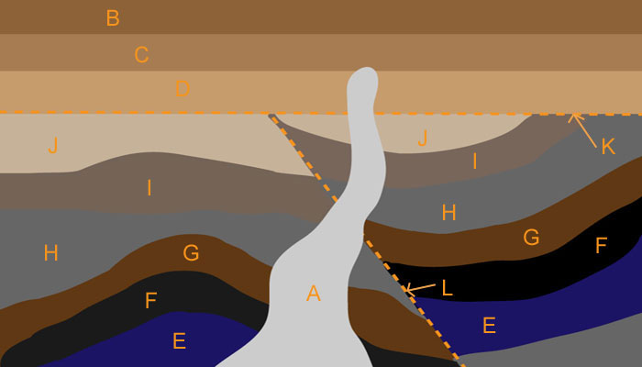

1. Deposition of sedimentary sequence E through J--- conformable
2. Folding of sequence E-J – original horizontality
3. Faulting – line L – cross cutting relationships
4. Erosion of the sedimentary sequence--- unconformity=plane K== crosscutting relationships
5. Deposition of next set of sediments– D, C, B - conformable=== superposition
6. Intrusion===igneous body A = crosscutting relationships

**Analysis of cross section of the Grand Canyon – 10 points**

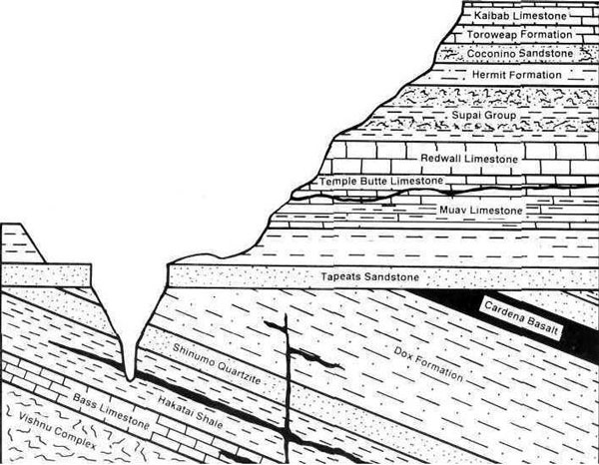To the right is a cross section through the Grand Canyon

Please provide an analysis of the sequence of events that resulted in this profile. Include the formation names and the geologic events that took place (faulting, intrusion, erosion etc.)

Use the sequence analysis above as an example

Extra tidbits of information – the Vishnu Complex is a schist – e.g. Metamorphic rocks – 1.7 billion years old.

The Cardena Basalt and the dike and sills in the Dox Formation is 1.07 by old

Extra credit (maximum of 5 points) Please provide an analysis of the cross section below.

